Excel Pivot Table Exercise
1.
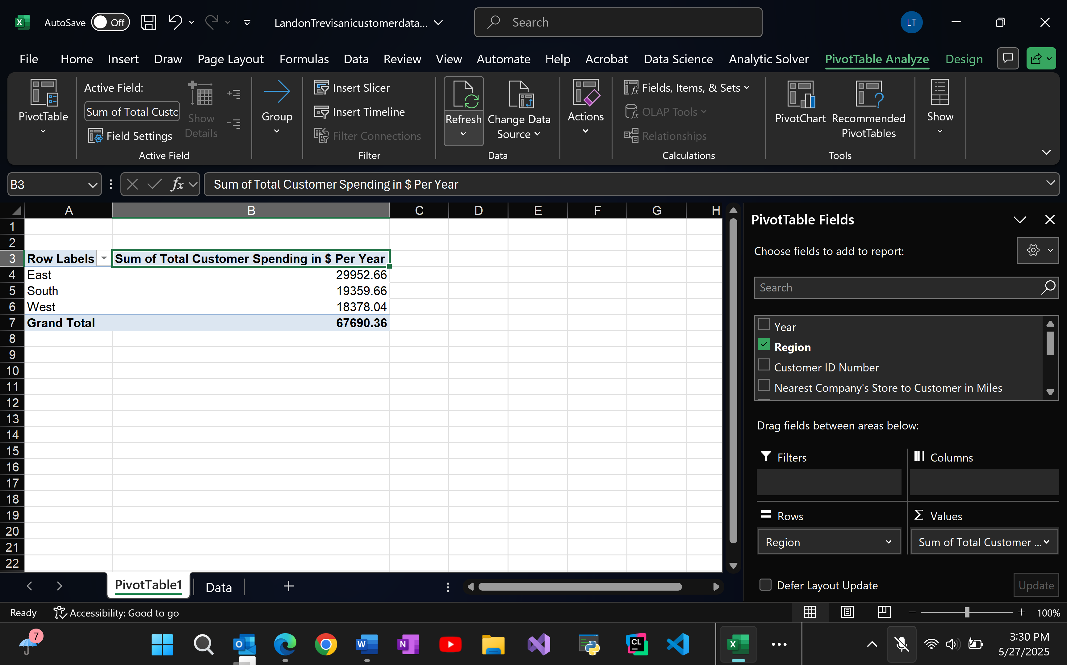
The eastern region is spending the most money per year, so it is doing the best. This could be based on a few things. There are plenty more categories to analyze and to consider, especially how many stores are in a certain area and the amount of money spent in a specific year not just the range of multiple
2.
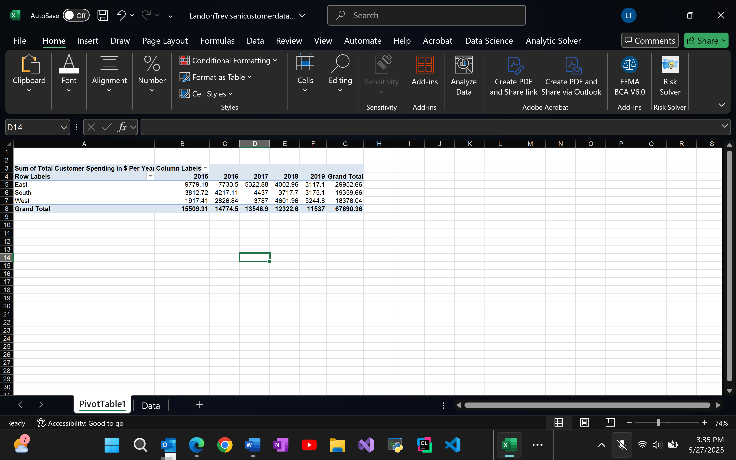
Based on the data it is obvious the eastern region has the highest grand total but has also been declining since 2015. Currently, in 2019, the eastern region has the lowest customer spending with the west with the most. The west is gradually increasing almost opposite of the eastern region. It’s almost as if a lot of consumers from the east and some from south moved more into the western region.
3.
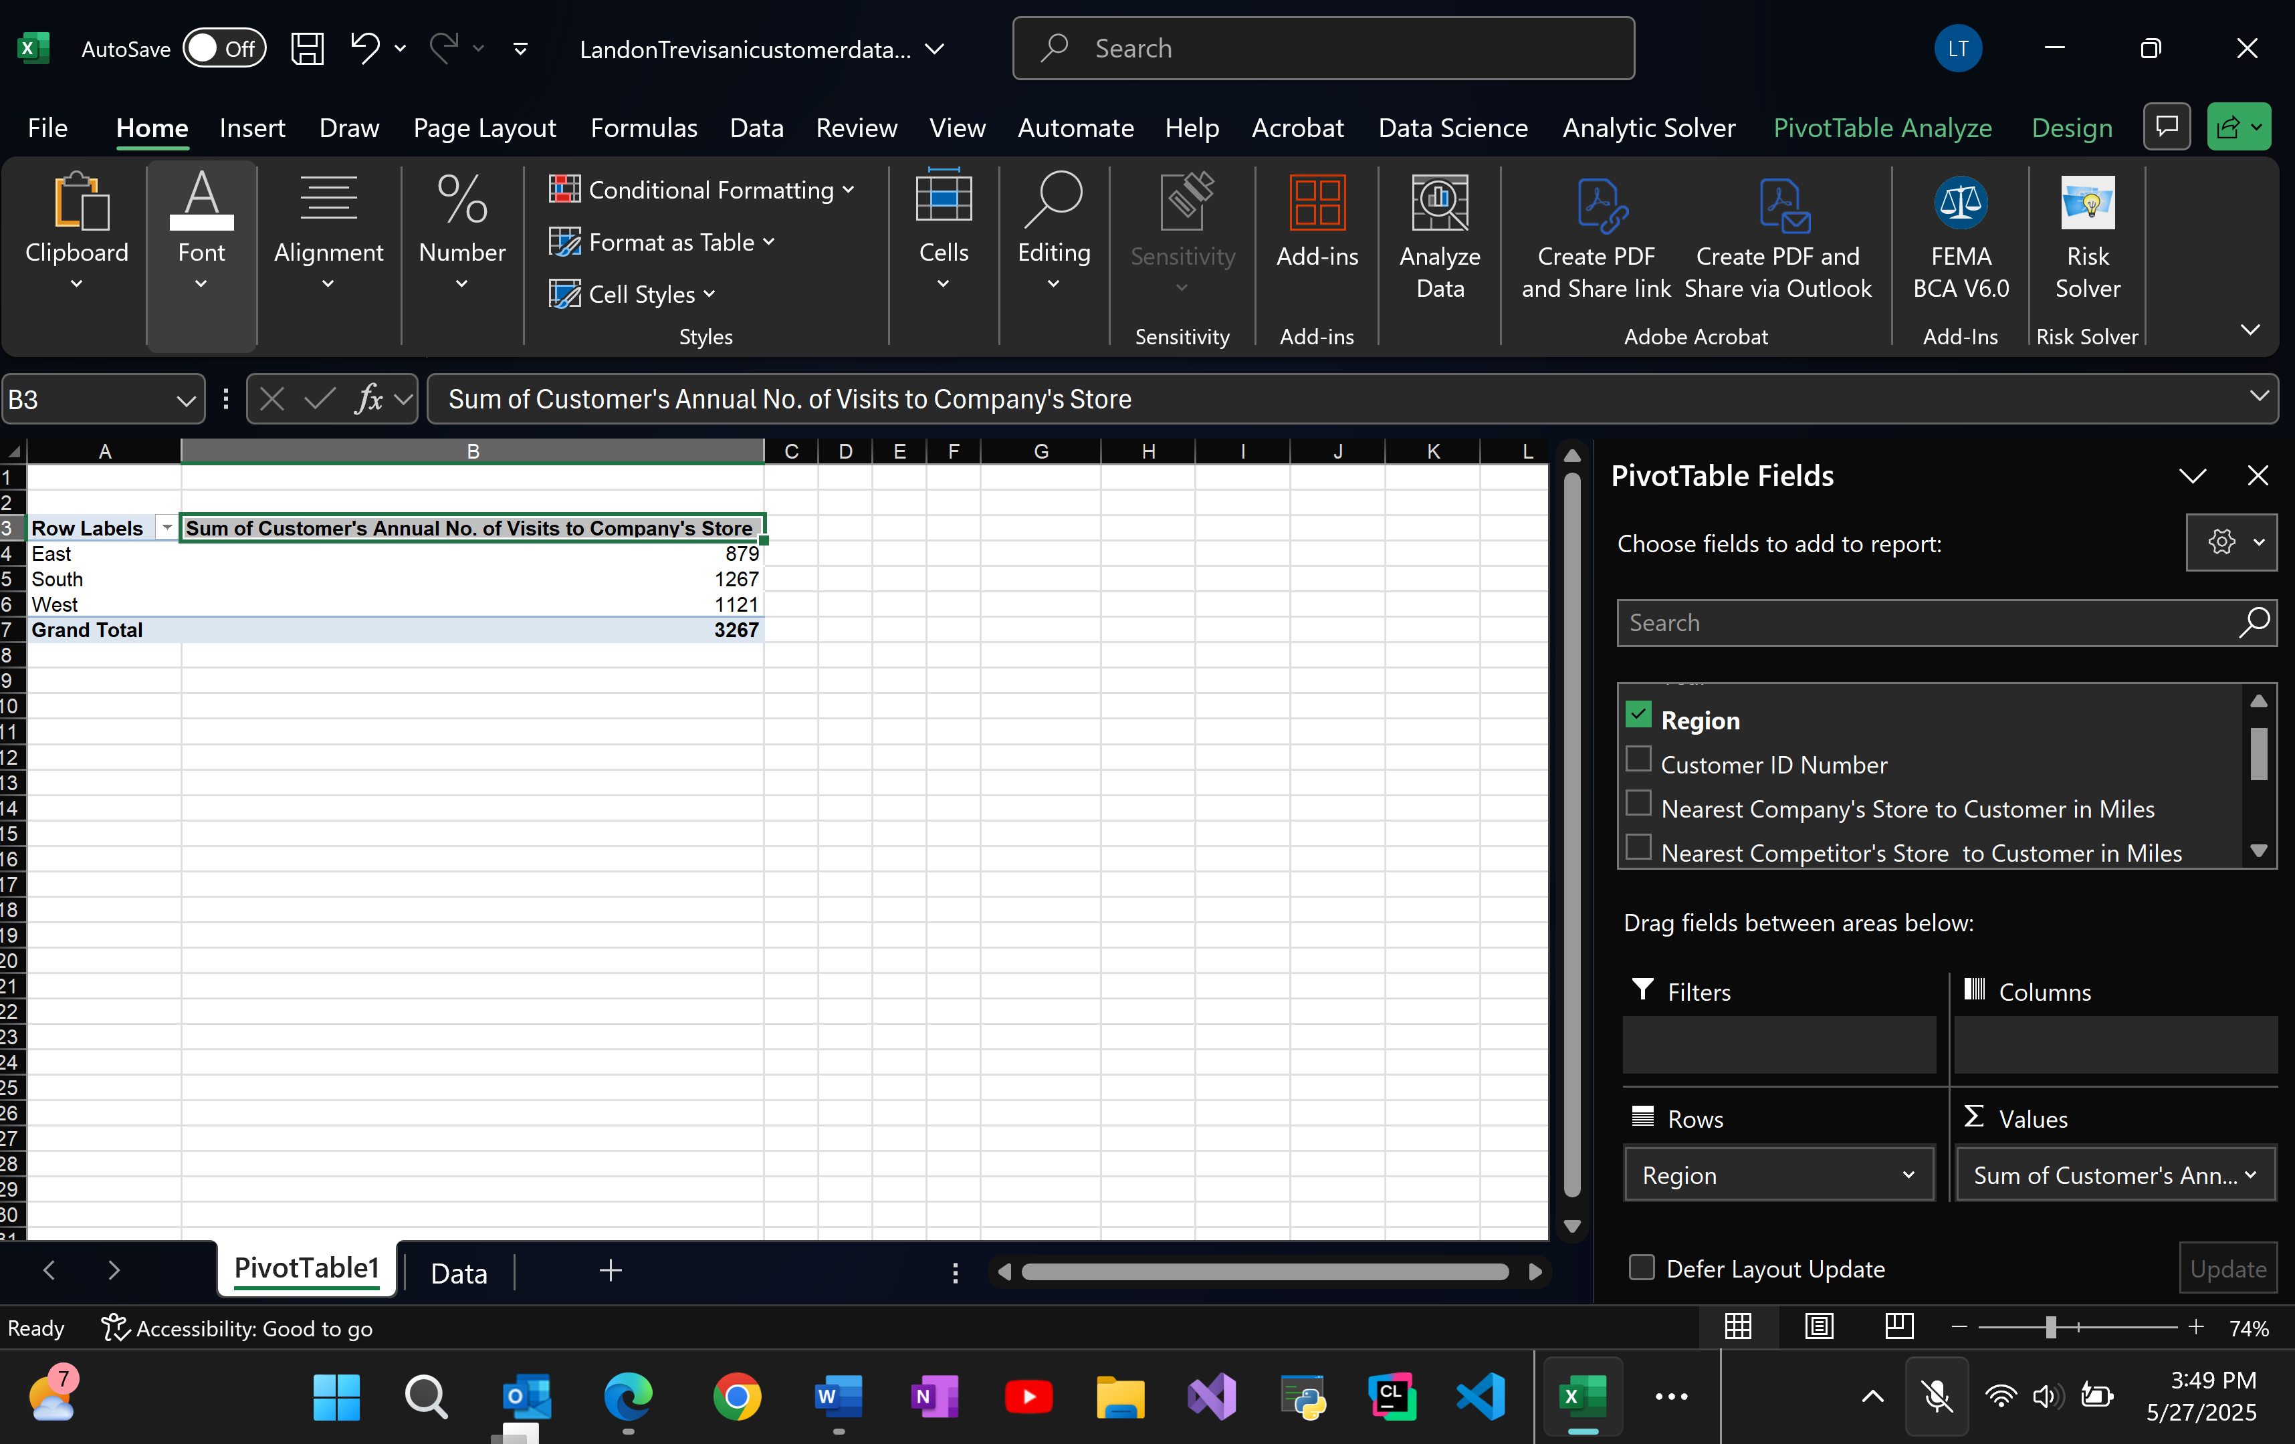
The southern region has the most annual number of visits to company stores while the East has the least. Stores are probably closer to consumers with cheaper prices or with customers only buying one or two things. This reasoning would align with the data from the previous examples. The sales weren’t the highest, but they received the most traffic, customer-wise.
4.
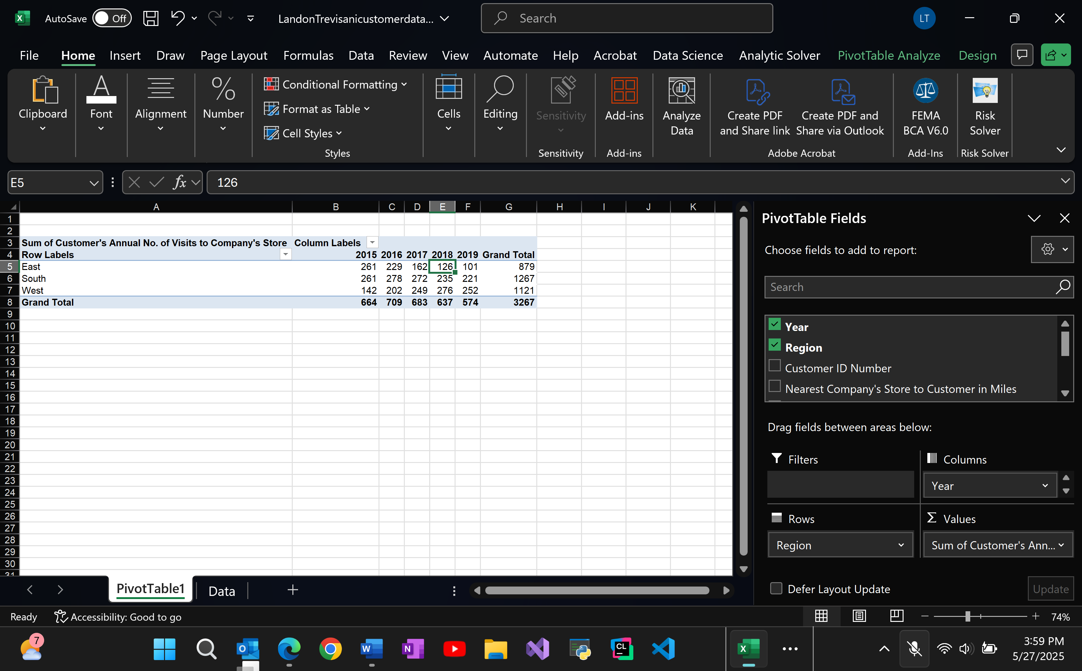
In total the southern region received the most visitors to their stores. However, this year (2019) the data seems to point more towards the western region. The western region seemed to have one bad year in 2015 which slightly skewed the totals. Knowing the west it could have been from fires, etc. I can’t be too sure.

5.
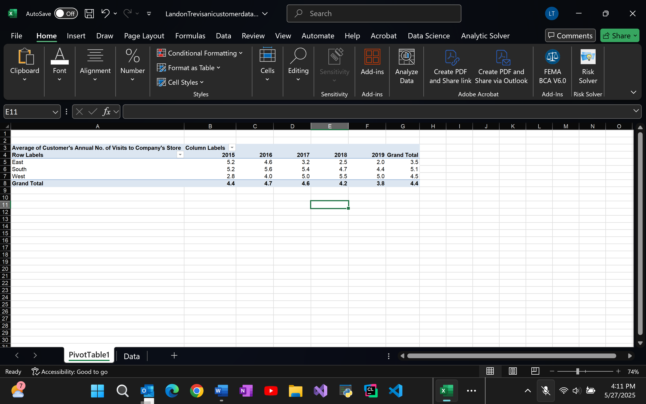
The South has the highest average number of visits to stores in that region. However, as of 2019 the trend for the West seems to be increasing and is the highest at 5.0 > 4.4 (South) > 2.0 (East). Earlier I also noticed the trend of the west spending more money which can be backed up by an increase in population or more stores opening up.
6.
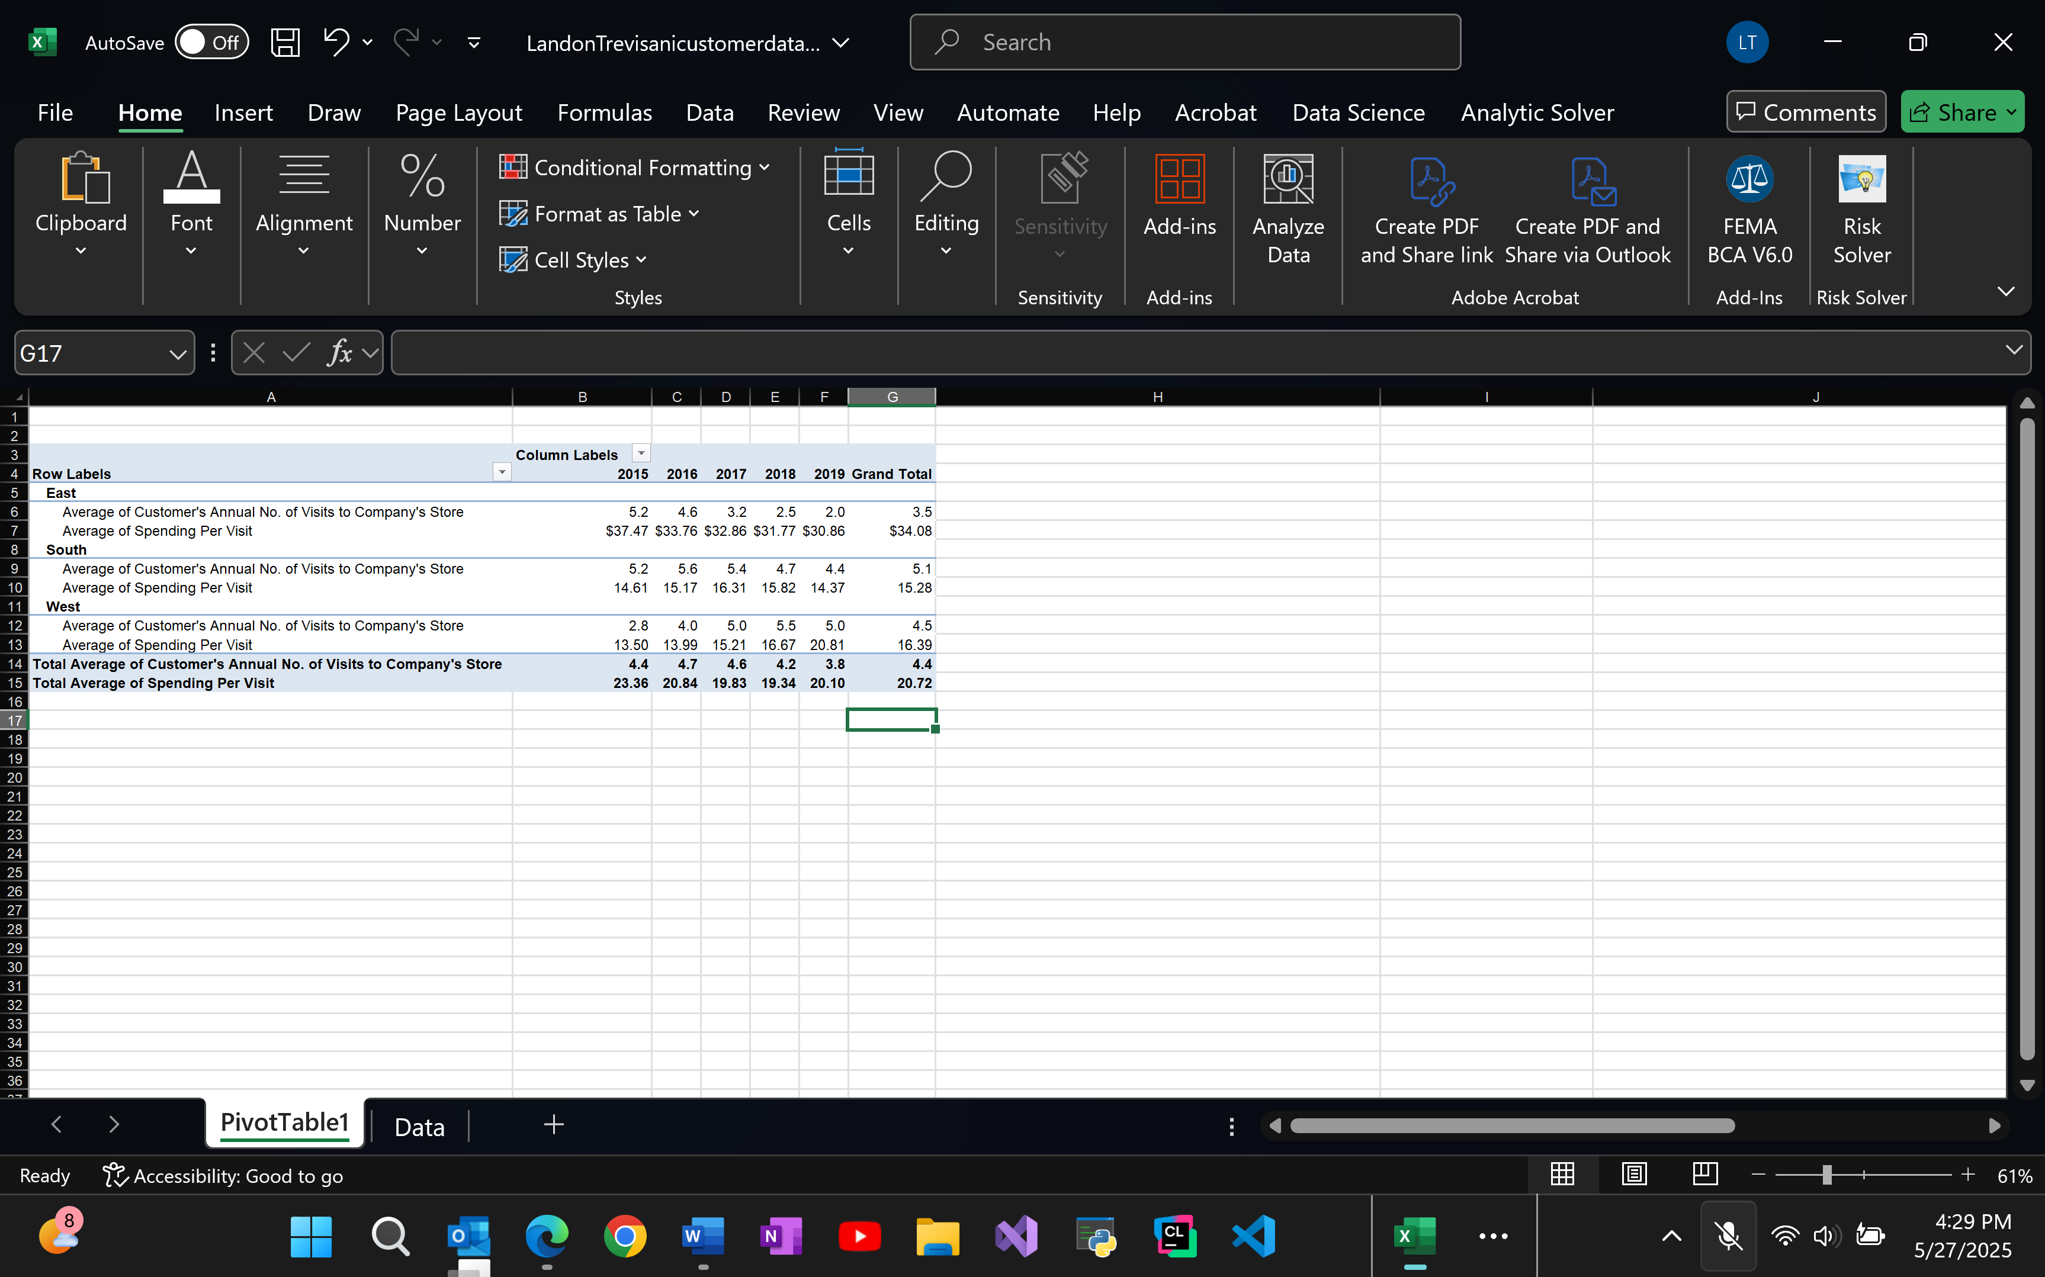
The east is doing the best while the south is doing the worst. It does get strange here as you could say the number of visits combined with the amount spent, could play a role in the total sales for these regions. East is the best because it sells the most per visit at $9.74/visit. The worst is the south at $2.99 spent per visit. West comes in at $3.64 per visit.
7.
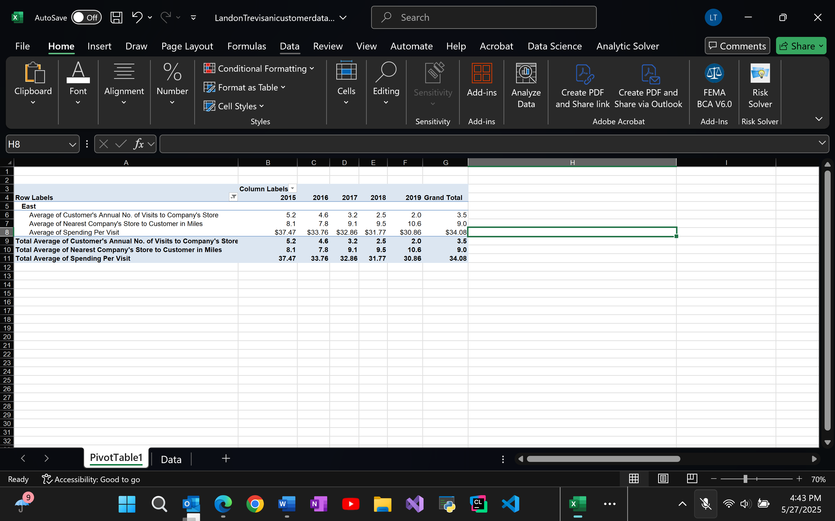
As the average distance between the customer and the company store increases the number of visits decreases. In 2015, the customers in the region visited an average of 5.2 times annually when the store was 8.1 miles away. Fast forwarding to 2019, the customers now visit 2 times annually yet the nearest store is 10.6 miles. The average spending has also decreased which shows the company is losing money because of the location of their company’s stores.

8.
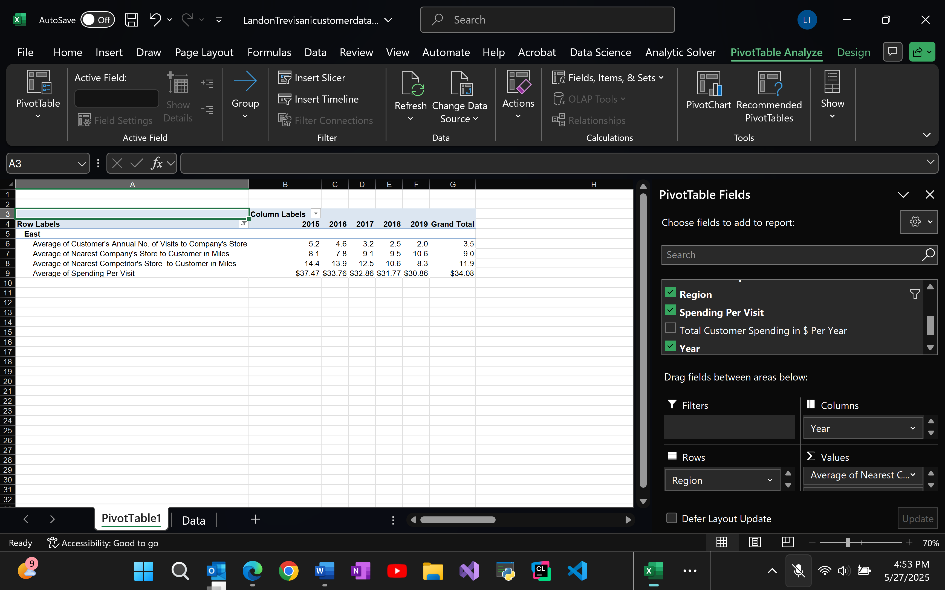
This image shows that the competitors are out competing this company in sales due to the fact that their stores are closer. The company used to have closer stores but over time they have gotten further and further away while the competitor’s stores grew closer.

9.
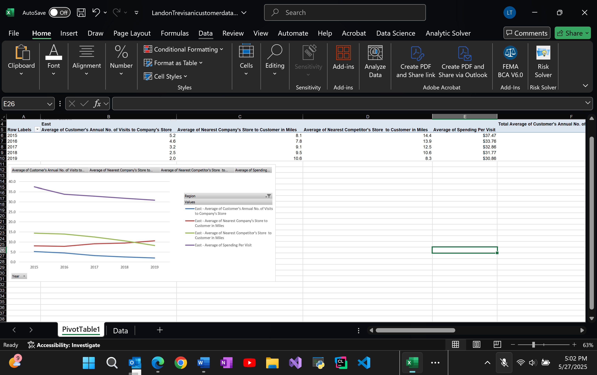
The chart confirms the idea that as distance increases, customer visits decrease. Spending per visit also slightly decreases overtime, which could go to show that the products they sell aren’t as wanted anymore. I believe the closer competitor also impacts the spending per visit.

